**Case Study #7 - Balanced Tree Clothing Co.**

**Introduction:**

Balanced Tree Clothing Company prides itself on providing an optimized range of clothing and lifestyle wear for the modern adventurer!

**Problem statement:**

Danny, the CEO of this trendy fashion company has asked you to assist the team’s merchandising teams in analyzing their sales performance and generate a basic financial report to share with the wider business

**Tools Used:** MySQL Server

**Table**:

Product_details table

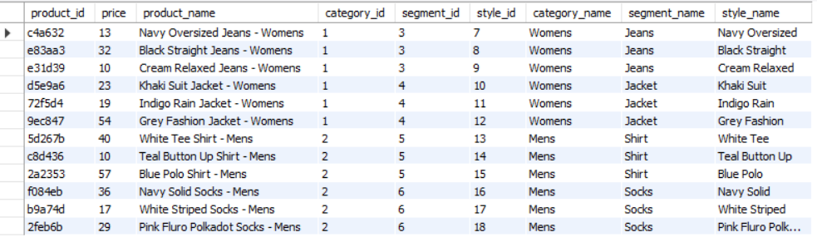

Sales table

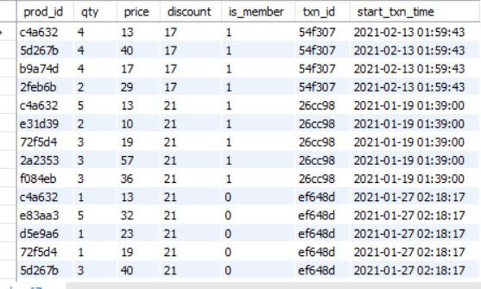

### 

### High-Level Sales Analysis

1. What was the total quantity sold for all products?

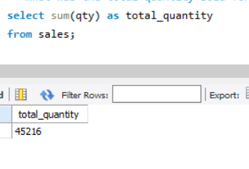

1. What is the total generated revenue for all products before discounts?

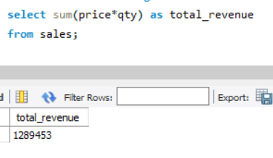

1. What was the total discount amount for all products?

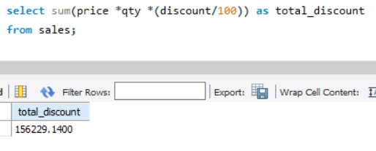

### Transaction Analysis

1. How many unique transactions were there?

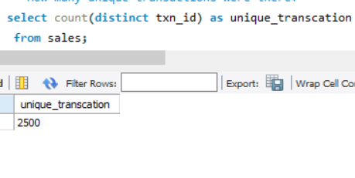

1. What is the average unique product purchased in each transaction?

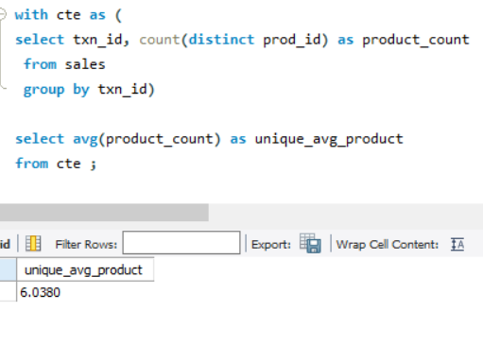

1. What are the 25th, 50th and 75th percentile values for the revenue per transaction?

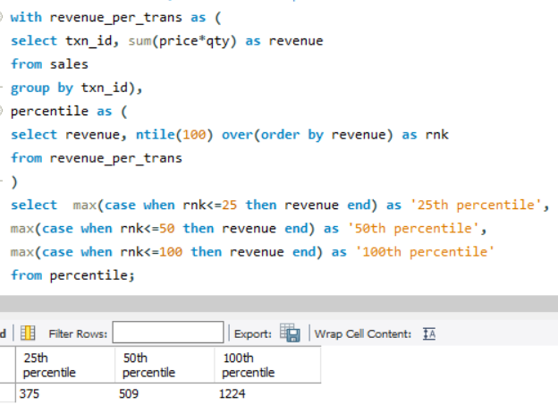

1. What is the average discount value per transaction?

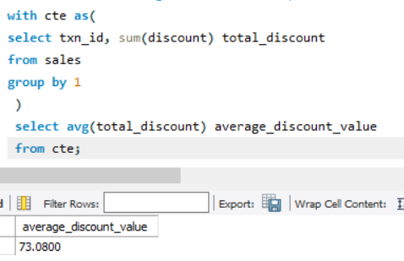

1. What is the percentage split of all transactions for members vs non-members?

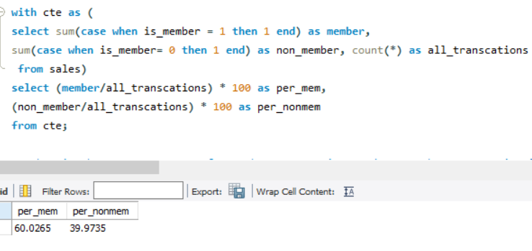

1. What is the average revenue for member transactions and non-member transactions?

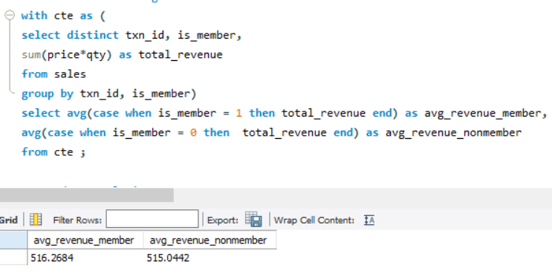

### Product Analysis

1. What are the top 3 products by total revenue before discount?

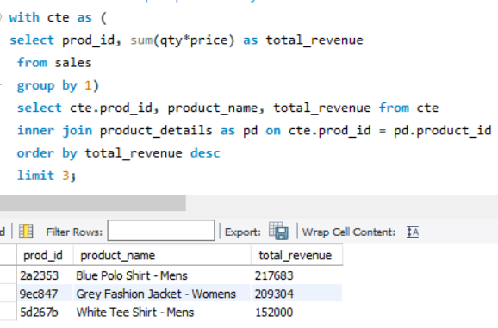

1. What is the total quantity, revenue, and discount for each segment?

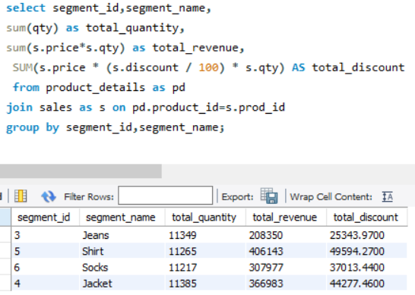

1. What is the top-selling product for each segment?

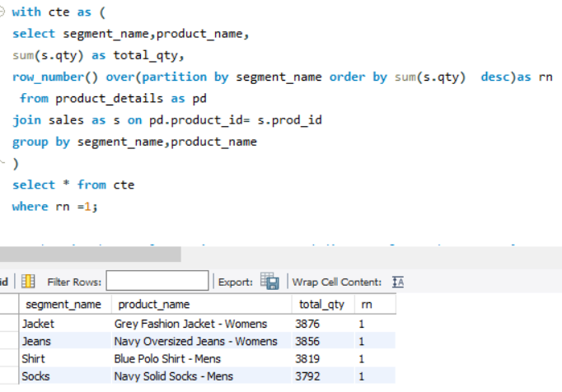

1. What is the total quantity, revenue and discount for each category?

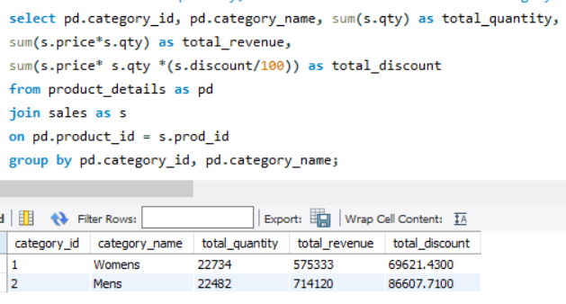

1. What is the top-selling product for each category?

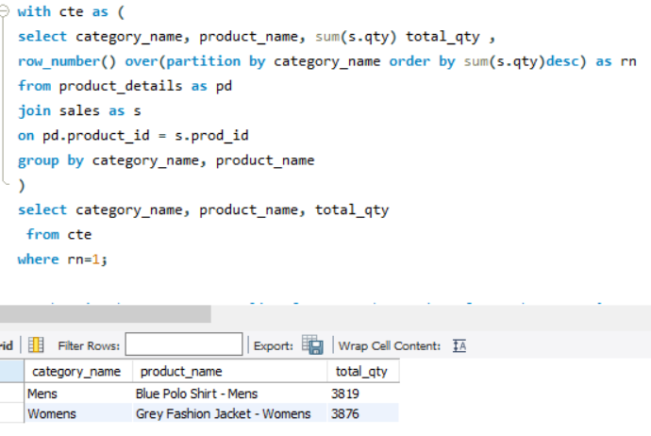

1. What is the percentage split of revenue by product for each segment?

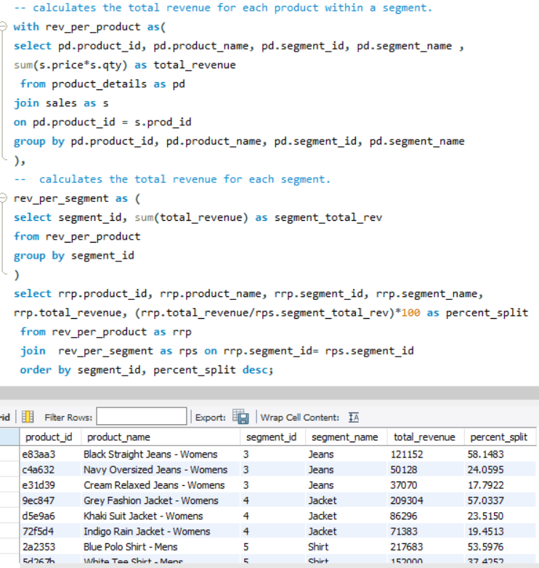

1. What is the percentage split of revenue by segment for each category?

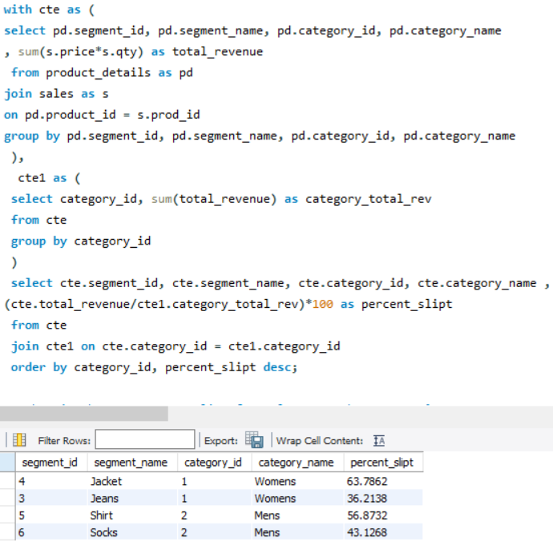

1. What is the percentage split of total revenue by category?

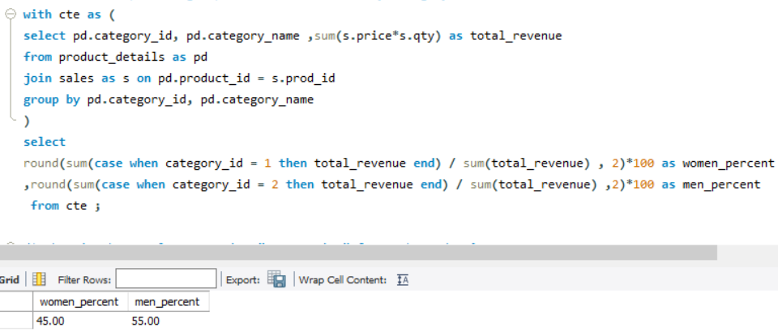

1. What is the total transaction “penetration” for each product? (hint: penetration = number of transactions where at least 1 quantity of a product was purchased divided by the total number of transactions)

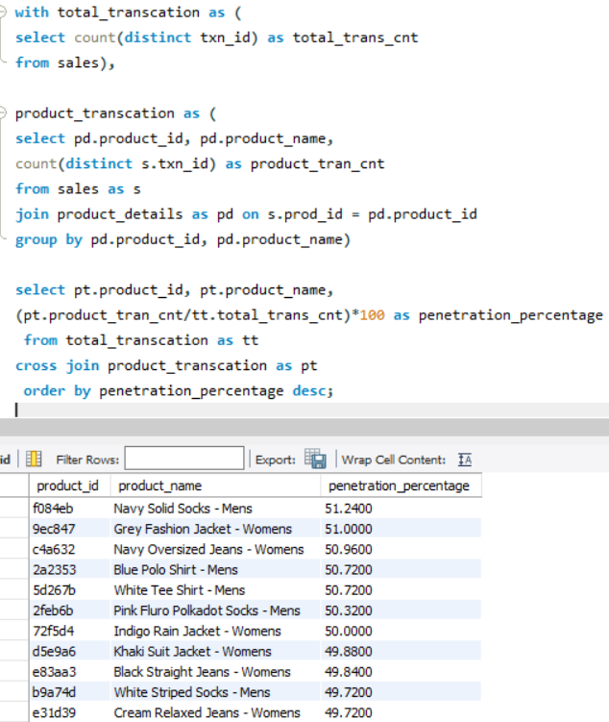

1. What is the most common combination of at least 1 quantity of any 3 products in a 1 single transaction?

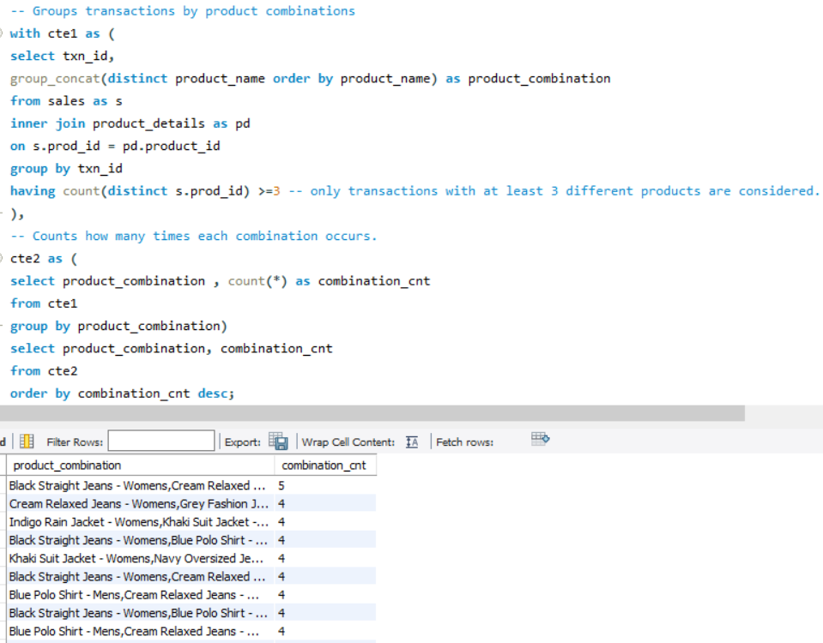

Key Findings and Observations

1. **Sales Overview:**

* **Volume**: A substantial volume of products was sold, with a total quantity of 45,216 items. This underscores the brand's popularity and market penetration.
* **Revenue**: Before considering discounts, the company generated an impressive revenue of **$1,289,453.** This is a testament to the brand's considerable sales capabilities and product appeal.
* **Discounts**: The products had varying discount amounts, with notable mentions being the **"Black Straight Jeans - Womens"** and the **"Blue Polo Shirt - Mens"** which had discounts amounting to **$14,744.96** and **$26,819.07** respectively. This indicates strategic pricing and promotional tactics employed by the company.

**2. Transaction Analysis:**

* **Volume & Diversity:** There were **2,500** unique transactions, with an average of **6** unique products in each transaction. This suggests a diverse shopping pattern among customers.
* **Revenue Distribution**: The median (50th percentile) revenue per transaction stood at $441.225, with the 25th and 75th percentiles at $326.405 and $572.7625 respectively. This highlights a significant spread in transaction values.
* **Membership Insights**: **Members** contributed to **60.2%** of all transactions, with an average revenue slightly higher ($454.13) compared to non-members ($452.01). This implies the importance of loyalty programs and member engagement strategies.

**3. Product Analysis:**

* **Top Performers:** The **"Blue Polo Shirt - Mens", "Grey Fashion Jacket - Womens", and "White Tee Shirt - Mens"** emerged as revenue leaders, collectively contributing to a significant portion of the company's sales.
* **Segment Insights**: **Jackets** led in the segments with a total revenue of **$366,983**, followed closely by Shirts and Jeans. This suggests seasonal or fashion trends influencing purchasing patterns.
* **Category Differentiation**: The **Men's** category **outperformed** the **Women's** category in revenue, making up **55.37%** of the total revenue. This indicates a potential market segment that could be further targeted for growth.
* **Product Penetration**: The product "**Navy Solid Socks - Mens"** had the highest penetration with **51.24%** of transactions including at least one purchase of this product. Such products can be deemed as popular or essential items in the product range.

**CONCLUSION**

﻿

This case study delves into the world of fashion retail, shedding light on sales patterns, product preferences, and customer behavior.

Through the use of MySQL, I was able to sift through vast amounts of data to uncover meaningful insights. SQL not only made the data more accessible but also transformed it into actionable information.

The insights gathered provide a clearer picture of consumer choices and preferences. Such knowledge is invaluable for businesses aiming to tailor their offerings or enhance their marketing strategies. This analysis, inspired by Danny's real-world experiences, underlines the significance of sales analytics in today's retail landscape.